Employers should give their staff at least 4 weeks’ holiday every year to make them work better at their jobs. To what extent do you agree or disagree?

雇主应该每年给员工至少4周的假期，让他们更好地工作。
Productivity/ creativity/
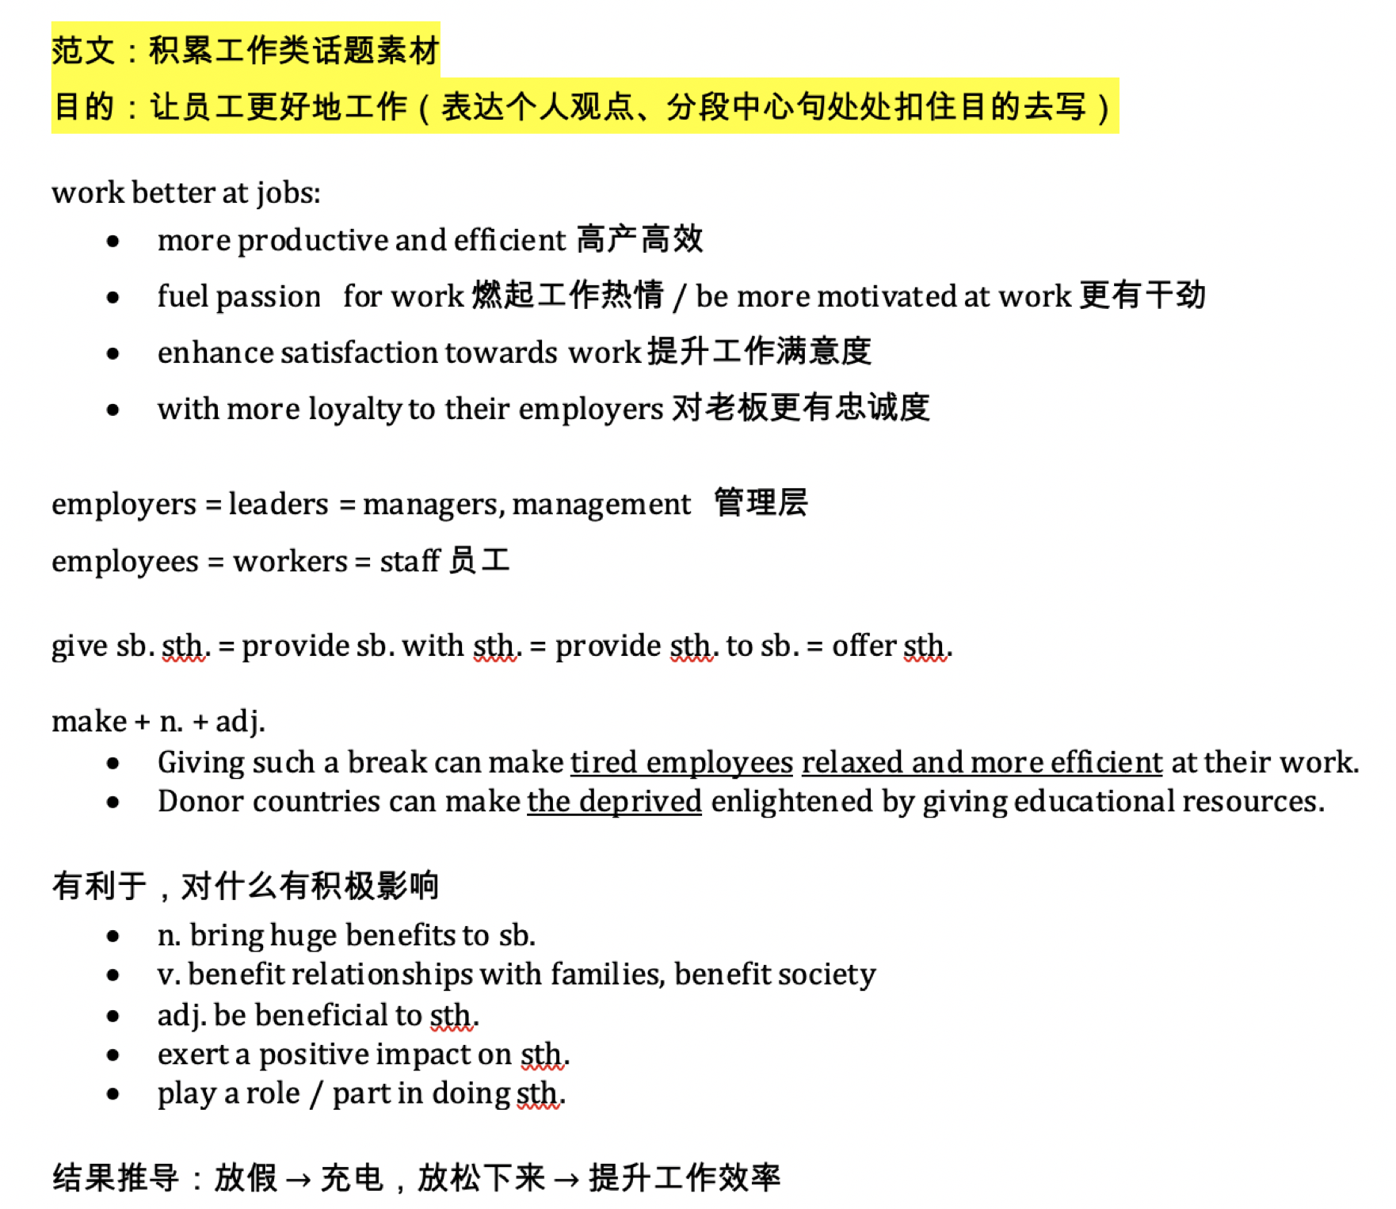


【开头段】①有一种观点认为，企业应该给予员工一个月的年假，以提高员工的工作效率(改写题目) 。 ②我同意这种观点，因为通过这样的休息，员工可以给自己充电，有利于与家人的关系，有助于提高工作效率(表明立场和理由)。

① There is a thought that companies should grant their staff a month of annual leave to make them more productive at work. ②I agree with this view as by having such a break, employees can recharge themselves and benefit relationships with their families, which can contribute to their productivity.

- 4 weeks’ holiday every year = a month of annual leave 1个月的年假
- Give staff holiday
  - grant staff holiday
  - offer paid holiday
  - be entitled to a holiday
- Make them work better at their jobs
  - Make them more productive at work
  - contribute to their productivity
  - improve productivity

- give sb. sth.
- offer sb. sth.
- grant sb. sth.
- provide sb. with sth.

- give sth. to sb.
- offer sth. to sb.
- provide sth. to sb.

选择立场后，列大纲时先写出主体段的中心句。
思考方向：假期对员工的重要性
【BP1】首先，给这样的假期可以让疲惫的员工放松下来，提高工作的效率。
【BP2】此外，与家人共度长假，可以提高劳动者对雇主的满意度，从而激发他们的工作热情。

【BP1】①首先，给这样的假期可以让疲惫的员工放松下来，提高工作的效率 (中心句)。②这是因为，人在经历了比较长时间的工作之后，需要换一种氛围，否则精神状态连同身体健康都会有所下降(解释)。③基于此，很多高科技公司如苹果、谷歌等都会给员工提供至少一个月的带薪假期，希望以此来恢复员工的活力(举例)。④如果没有这样的政策，考虑到这些机构的高工作量，员工会更容易感到疲惫，从而导致生产力下降(反向论证)。

①First of all, giving such a vacation can make tired employees relaxed and more efficient at work. ②This is because, after a relatively long period of working, people need to have a change of atmosphere; otherwise their mental fitness, together with physical health, may decline. ③Based on this, many high-tech companies such as Apple and Google offer their employees paid holidays of at least a month, hoping this can restore their vitality. ④If there were no such policy in place, considering the high workload in these organizations, their workers would be more likely to feel enervated, which would result in a drop in productivity.

- Have a change of atmosphere 换一种氛围
- Mental fitness 精神状态
- Physical health 身体健康
- Restore vitality /vaɪ'tælɪtɪ/ 焕发活力
- Feel enervated /'enə:veitid/ 疲惫的，无力的
- High workload 高工作量

【BP2】①此外，与家人共度长假，可以提高劳动者对雇主的满意度，从而激发他们的工作热情(中心句)。②家庭关系对一个人的工作满意度有着巨大的影响。③当一个人被赋予与家人共度一个快乐的假期时，他与家人的情感纽带就会得到加强，使他更加投入到工作中去(解释)。④相反，如果他长期没有与所爱的人共度美好时光，他可能会遭受家庭关系的恶化，精神压力更大，心烦意乱(反向假设)。⑤导致他无法专注于工作，工作效率直线下降(进一步的结果)。

① Furthermore, spending a long holiday with families can enhance workers’ satisfaction towards their employers and thus fuel their passion for work. ② Family relationships have a tremendous influence over a person’s job satisfaction. ③ When an individual is entitled to a happy holiday with his families, his emotional bonds with family members will be strengthened, making him more committed to his job. ④ In contrast, if he did not have quality time with those he loves for a long term, he might suffer a deterioration in family relationship, having more mental stress and distractions. ⑤ As a result, he could not focus on his work, with his efficiency plummeting.

- Enhance satisfaction towards sb. 提高对谁的满意度
- Fuel passion for work 激发对工作的热情
- Strengthen emotional bonds 增强情感纽带
- Be more committed to job 更投入到工作中
- Quality time 美好时光
- Suffer a deterioration in family relationship 遭受家庭关系的恶化
- Mental stress 精神压力
- Distractions 心烦意乱

【总结段】①总之，雇主有必要保证员工每年有4周的假期。②这样可以使员工因精力充沛、家庭关系改善而提高工作效率。

① In conclusion, it is necessary for employers to guarantee a four-week vacation to their staff annually. ② This can make employees more productive at work due to the boosted energy level and improved family relationships.

